Project 2.0: Fourier series

Here You can see that, I have used this equation showed in fig 1 to slove the coefficient a0, an & bn. And then find sf(t). In this program the simple approach was given. 1) initialize the variables for making array of desired functions(f(t), sinusoidal function) 2) From the array, I found the a0, an & bn value by using trapz function in matlab, that directly gives the value of area under the curve. (here 1st loop I have made to find the value of a0 & then save that value of a0 in the variable ft and the 2nd loop is used to find the value of an & bn where n is continuously increases by 1 and plotting the required graphs). In my code plot’s lower & upper boundary is predefined, which is -10 & 10 Respectively. And the number of sample is predefined, which is 10000. All the graphs are staring from 0 without the delay.in the Code, Step width is from where you need to stop plotting that individual function(like step, ramp), after this point y(t) should be zero.

Fourier series Equation used

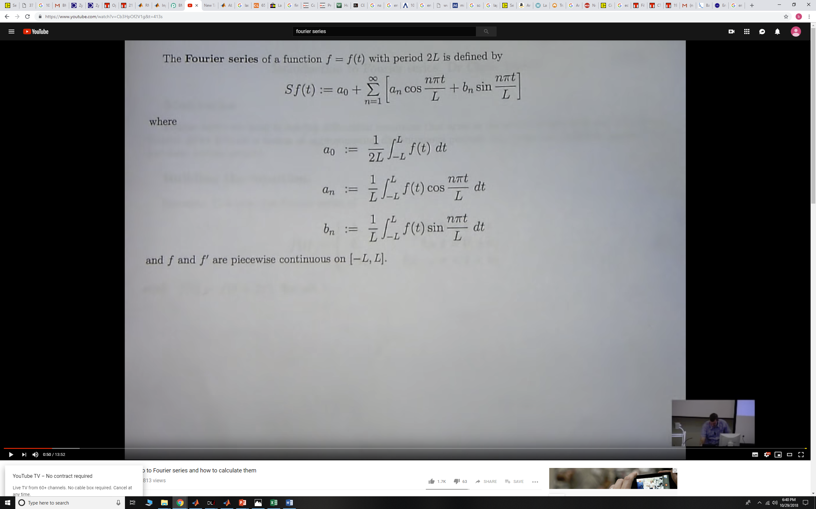

Fig 1: Fourier series formulas:

Logic to find the a0, an & bn & sf(t)values from matlab:

we=y.*z; % Multiplication of the signal f(t) & sin function to find the value of Bn

yu=w.*y; % Multiplication of the signal f(t) & Cos function to find the value of An

omaga=2*pi/L; % Find the value of Omaga

A0=trapz(n,y)/T0;% equation for A0

An=(trapz(n,yu)/L);% find the area under the curve basically find the value of An

Bn=(trapz(n,we)/L);% find the area under the curve basically find the value of Bn

ft(x)=ft(x)+(An*cos(D*pi*x/(a*L))+Bn*sin(D*pi*x/(a*L)));

Here I have used the same formulas as we see in the fig 1 to find the coefficient. The basic logic behind the to find the sf(t) is , in my 1st loop I have saved the value of a0 in f(t), then in loop 2 , I am starting it by 1 calculate a1,b1 & find the ft(x). then it is added in ft(x). so this ft(x) is basically the summation of n=0 term & n=1 term. After that loop changes the value from 1 to 2, and again calculate it. summing the terms and plotting it.

For finding the error in the both signals, I have used root mean square error equation shown below.

RMSE=(sqrt(mean((y-ft).^2)))*100;

When this error is going below 5%, graph will stop plotting.

Comparing the results:

(-L,L)=(-10,10), To=20, f(t)=2 where 0<=t<=3

|  |  |  |  |  |
| --- | --- | --- | --- | --- |
| n | By hand An | By code An | By hand Bn | By code Bn |
| 1 | 0.5151 | -0.5151 | 0.2626 | -0.2626 |
| 2 | 0.3029 | 0.3029 | 0.4169 | 0.4169 |
| 3 | 0.06589 | -0.06589 | 0.4140 | -0.4140 |

In, My code I do know there is a mistake either in calculating the value of An & bn by hand or by code. But still the value is same. And the plotting is quite accurate.